michelle.roberts

CentralSquare Technologies

Docs Online

a practical guide for Connecting Cognos to Docs online

Table of Contents

Concept 2

Drill-Through to Documents Online functionality from a Cognos report 2

Prerequisites 3

What is Documents online 4

Attachment Definitions 4

What does a Link to DocsOnline Look Like? 4

First things first 4

Steps to build a Docs Online Link 5

ServerUrl 5

Arguments 5

Environment 6

User 6

Token 6

URL 7

Add HTML to the Report Page 7

Link to DocsOnline 8

One Last Thing 9

Trouble shooting 10

**Docs Online**

# Concept

The Concept With this instruction is to connect a Cognos report (like a Drill through) to a document kept in the client documents repository. That repository is called Docs Online(DOL). There are several steps involved in successfully setting up a DOL Link.

There is an xml document attached that provides a sample of how it is all set up successfully – the best thing to do is paste this sample on the client system to use as a model to test and it will have the sql and functions needed for each field and HTML tag.

# Drill-Through to Documents Online functionality from a Cognos report

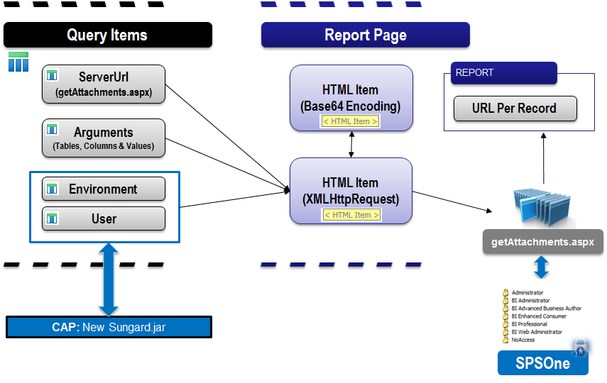

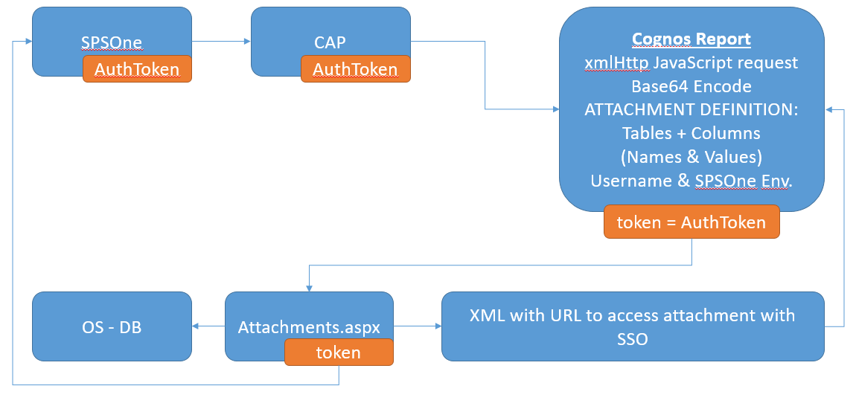

## Prerequisites

* **Cognos Report Studio:** Advance reporting techniques
* **FE Attachment Definitions**: General technical understanding
  + Knowledge of attachment definition table and column items tied to image type looking to drill-to.
* **FE Documents Online:** Basic Understanding
* **JavaScript:** Basic understanding
* **Latest CAP Files**
* **Host Name:** Location in the network for **getAttachments.aspx** file

*e.g. http://****<hostname>****/Finance/Documents/getAttachments.aspx*

## 

## What is Documents online

Documents Online provides you with the ability to store images in the database and relate those images to information in Finance.

## Attachment Definitions

The Attachment Definition controls which Tables and Columns will be used to link a Document to Finance Data. This can be as simple as a link to a single table or a more complex link referred to as “Document Progression”.

## What does a Link to DocsOnline Look Like?

Report output:

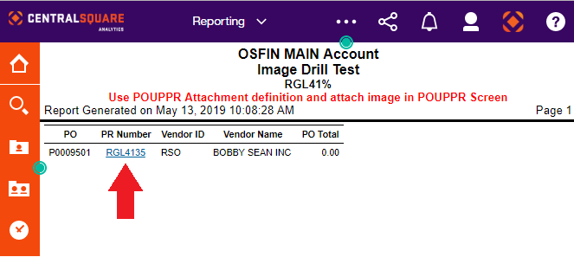

Click on report link to open attachments from Documents Online:

# First things first

Get the text doc Named QA300 - PO Base - With Drill to Docs Online 191 (it contains the xml for a sample report)– open it in a text editor and copy it all – go to Cognos create a new blank report and paste the xml and save it as whatever you choose to call it.

Open Finance Enterprise(FE) and locate the where you would get a particular document, in this case it is we will link a PO. The screen POUPPR has the link to the Docs online for PO’s.

* Open a Document.
* When the PDF Opens look at the web-address, you are going to need a portion of it for the steps to link docs, so keep that doc open for now.

Open the Report intended to use the docs online link (NOTE: The PO Status Report already has Java Scripts for the functionality of that report and the new scripts cause the links to not work, so choose any other report)

Now you have everything you will need to build your docs online link from your report.

# Steps to build a Docs Online Link

There are 6 Query Items to build in the query in which the report uses. They all need to be spelled exactly as they are presented

## ServerUrl

* Create an new Data Calculation
* Name it **ServerUrl**
* Go to the previously opened PO (PDF) document
* Start the expression off with a single quote (‘) and end with a single quote (‘)
* Extract the Server portion of the web address (https://....../Finance/Documents )and paste it into the Expression box.
* Add this after the ‘*https://....../Finance/Documents*/getAttachments.aspx?arg='
* The Expression Box should look like :

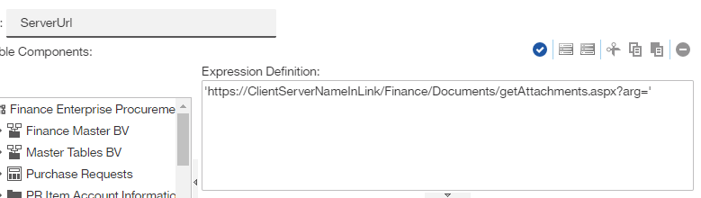

It should lookgetAttachments.aspx?arg='

* Close the Data Calculation

## Arguments

The Arguments Data Item is to translate the database table.field to what it is named in the query

* Create a new Data Calculation
* Name it **Arguments**
* Identify the table name from the database in this case for the PO Number it is it is **POP_PV_DTL**
* The Database field name is **POP_PO_NO**
* And the field is named **PO Number** in the report query (note in the below example you are bringing in the field from the query hence the [braces] around PO Number)
* This is how it is laid out: (use the Arguments field in the sample report you pasted earlier or the provided snippet below and simply change the tables and fields as needed)

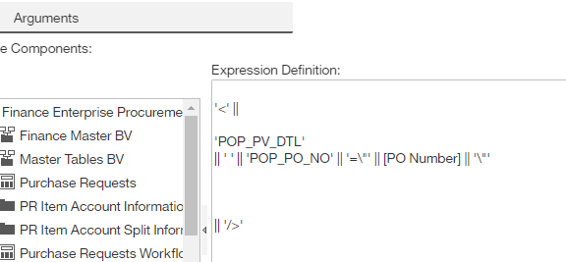

'<' ||

'POP_PV_DTL'

|| ' ' || 'POP_PR_NO' || '=\"' || [PR Number] || '\"'

|| '/>'

NOTE multiple Fields can be used see example report

## Environment

* Create a new data calculation
* Name it **Environment**
* Paste the SQL exactly as it is and close it

'&env=' || #sq($account.parameters.ActiveEnvironment)#

## User

* Create a new data calculation
* Name it **User**
* Paste the SQL exactly as it is and close it

'&env=' || #sq($account.parameters.ActiveEnvironment)#

## Token

* Create a new data calculation
* Name it **Token**
* Paste the SQL exactly as it is and close it

# sq(URLEncode($account.parameters.AuthToken)) #

## URL

The URL Script requires some additional updates.

* Create a New Data Calculation
* Name it **Environment**
* Past the Script in the Expression Definition
* Everywhere that you see [PO Master] has to be changed to the name of the query that is being updated. Do Not change anything else.

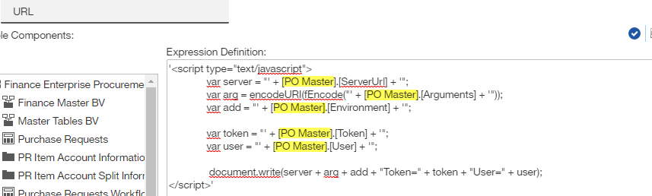

'<script type="text/javascript">

var server = "' + [PO Master].[ServerUrl] + '";

var arg = encodeURI(fEncode("' + [PO Master].[Arguments] + '"));

var add = "' + [PO Master].[Environment] + '";

var token = "' + [PO Master].[Token] + '";

var user = "' + [PO Master].[User] + '";

document.write(server + arg + add + "Token=" + token + "User=" + user);

</script>'

# Add HTML to the Report Page

There are 2 Html Items to add to the report page. The first one is placed just BEFORE the report List and the second is placed in the query in place of Item you are linking to docs Online with. Like PR Number or PO Number or Invoice. The filed can beaded as a new field with a heading of Link to Documents if that is preferable.

* Go to the Tools Icon then to the advanced section
* Drag an HTML Item and position it just before the Report List.
* Paste the Script and change NOTHING

<script type="text/javascript">

function fEncode(vValue) {

var Base64={_keyStr:"ABCDEFGHIJKLMNOPQRSTUVWXYZabcdefghijklmnopqrstuvwxyz0123456789+/=",encode:function(e){var t="";var n,r,i,s,o,u,a;var f=0;e=Base64._utf8_encode(e);while(f<e.length){n=e.charCodeAt(f++);r=e.charCodeAt(f++);i=e.charCodeAt(f++);s=n>>2;o=(n&3)<<4|r>>4;u=(r&15)<<2|i>>6;a=i&63;if(isNaN(r)){u=a=64}else if(isNaN(i)){a=64}t=t+this._keyStr.charAt(s)+this._keyStr.charAt(o)+this._keyStr.charAt(u)+this._keyStr.charAt(a)}return t},decode:function(e){var t="";var n,r,i;var s,o,u,a;var f=0;e=e.replace(/[^A-Za-z0-9\+\/\=]/g,"");while(f<e.length){s=this._keyStr.indexOf(e.charAt(f++));o=this._keyStr.indexOf(e.charAt(f++));u=this._keyStr.indexOf(e.charAt(f++));a=this._keyStr.indexOf(e.charAt(f++));n=s<<2|o>>4;r=(o&15)<<4|u>>2;i=(u&3)<<6|a;t=t+String.fromCharCode(n);if(u!=64){t=t+String.fromCharCode(r)}if(a!=64){t=t+String.fromCharCode(i)}}t=Base64._utf8_decode(t);return t},_utf8_encode:function(e){e=e.replace(/\r\n/g,"\n");var t="";for(var n=0;n<e.length;n++){var r=e.charCodeAt(n);if(r<128){t+=String.fromCharCode(r)}else if(r>127&&r<2048){t+=String.fromCharCode(r>>6|192);t+=String.fromCharCode(r&63|128)}else{t+=String.fromCharCode(r>>12|224);t+=String.fromCharCode(r>>6&63|128);t+=String.fromCharCode(r&63|128)}}return t},_utf8_decode:function(e){var t="";var n=0;var r=c1=c2=0;while(n<e.length){r=e.charCodeAt(n);if(r<128){t+=String.fromCharCode(r);n++}else if(r>191&&r<224){c2=e.charCodeAt(n+1);t+=String.fromCharCode((r&31)<<6|c2&63);n+=2}else{c2=e.charCodeAt(n+1);c3=e.charCodeAt(n+2);t+=String.fromCharCode((r&15)<<12|(c2&63)<<6|c3&63);n+=3}}return t}}

var encodedString = Base64.encode(vValue);

return encodedString;

}

</script>

# Link to DocsOnline

The HTML Link is exactly the same as the URL Query Item

* Unlock the report
* Cut The Item you Identified in the Arguments field (in this case PO)
* Drag an HTML Item into the field
* Copy the Script for the Link to DocsOnLine
  + Paste the script in the Expression Definition
  + Edit (similarly to the URL Query Item)the Query Name to match the name of the query used to identify all of the parts.

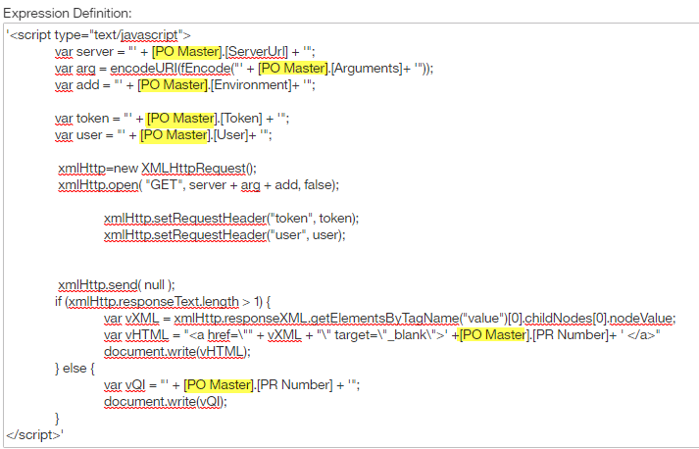

'<script type="text/javascript">

var server = "' + [PO Master].[ServerUrl] + '";

var arg = encodeURI(fEncode("' + [PO Master].[Arguments]+ '"));

var add = "' + [PO Master].[Environment]+ '";

var token = "' + [PO Master].[Token] + '";

var user = "' + [PO Master].[User]+ '";

xmlHttp=new XMLHttpRequest();

xmlHttp.open( "GET", server + arg + add, false);

xmlHttp.setRequestHeader("token", token);

xmlHttp.setRequestHeader("user", user);

xmlHttp.send( null );

if (xmlHttp.responseText.length > 1) {

var vXML = xmlHttp.responseXML.getElementsByTagName("value")[0].childNodes[0].nodeValue;

var vHTML = "<a href=\"" + vXML + "\" target=\"_blank\">' +[PO Master].[PR Number]+ ' </a>"

document.write(vHTML);

} else {

var vQI = "' + [PO Master].[PR Number] + '";

document.write(vQI);

}

</script>'

# One Last Thing

The Last Thing to do is add and hide all of the fields created. ServerUrl, Arguments, Environment, User, Token, & URL

* Add fields to the end of the report
* Select them all with their column Headers and change the background color to Yellow
* With all six fields and column headers still selected in the properties pane in the Box Section change the Box Type to None. This will make the columns disappear from the report but continue to make them available for the HTML and Javascripts.
* Run the report.
  + The PO Number, Invoice Account or PR Number designated in the **Arguments** should appear as a Hyperlink where ever the **List HTML** Item was placed.

# Trouble shooting

* When you run the report and the Hyperlink does not show up
  + Check that the Query Items and the items in the URL and the List HTML Item are all spelled the same
  + Insure the Query name has been changed to the query name you put the new Items in; in both the List HTML Item and the URL query item.
* If you get a server error
  + Insure you got the entire server information from the PDF that popped up when you opened a Doc from FE (for Items relating to POs use the screen POUPPR)
  + It should look something like this https://ClientServerNameInLink/Finance/Documents/